Loan Approval Prediction Using Machine
Learning

A Project Report

Submitted by
SHAHEEN M

ABSTRACT

Loan approval is an important process in the banking and financial sector. Financial institutions receive numerous loan applications daily and must determine whether applicants are eligible for loans. Manual evaluation can be time-consuming and may lead to inconsistent decisions. This project develops a Machine Learning-based Loan Approval Prediction System that predicts whether a loan application will be approved or rejected. The dataset contains applicant information such as gender, marital status, income, education level, loan amount, credit history, and property area. Data preprocessing techniques were applied to handle missing values and encode categorical variables. Multiple machine learning models including Logistic Regression, Decision Tree, and Random Forest were trained and evaluated. Hyperparameter tuning was performed to improve model performance. The final model provides accurate predictions and can assist financial institutions in making faster and more reliable loan approval decisions.

TABLE OF THE CONTENTS

S.NO Title Page No

Abstract

- INTRODUCTION 4
- PROBLEM STATEMENT 5
- DATASET DESCRIPTION 6
- METHODOLOGY 7
- ARCHITECTURE DIAGRAM 8
- RESULTS AND EVALUATION 9
- ADVANTAGES AND APPLICATIONS 10
- CONCLUSION 10
- FUTURE SCOPE 11
INTRODUCTION

Loan approval prediction is a classification problem where the goal is to determine whether a loan applicant is eligible for approval based on various attributes. Traditional loan evaluation methods involve manual assessment of financial records and customer information. These methods are often time-consuming and may introduce human bias. Machine Learning offers a data-driven solution that can automate the approval process by identifying patterns from historical loan records.

Objectives
- Analyze loan applicant data.
- Perform data cleaning and preprocessing.
- Train multiple machine learning models.
- Compare model performance.
- Optimize the best model.
- Predict loan approval status.

PROBLEM STATEMENT

Banks and financial institutions need an efficient method to evaluate loan applications. Incorrect approvals may lead to financial losses, while incorrect rejections may result in loss of potential customers.The challenge is to build a machine learning model that accurately predicts whether a loan application should be approved or rejected based on applicant information.

Expected Outcome
Develop a predictive model capable of assisting financial institutions in making informed loan approval decisions.

DATASET DESCRIPTION

Dataset Information
Dataset Source:
Loan Approval Prediction Dataset
Feature | Description
Gender | Applicant Gender
Married | Marital Status
Dependents | Number of Dependents
Education | Education Level
Self-Employed | Employment Status
CoapplicationIncome | Co-applicant Income
LoanAmount | Requested Loan Amount
Loan_Amount_Term | Loan Duration
Credit_History | Credit Score History
Property_Area | Urban/Rural/Semiurban
Loan_Status | Approved or Rejected
ApplicationIncome | Applicant Income

Features

Target Variable
Loan_Status
- Y = Approved
- N = Rejected
METHODOLOGY

Step 1: Data Collection
Loan prediction dataset collected from Kaggle.

Step 2: Data Cleaning
- Missing value treatment
- Data validation
- Feature selection

Step 3: Data Encoding
Categorical variables converted into numerical format using Label Encoding.

Step 4: Train-Test Split
- Training Data = 80%
- Testing Data = 20%

Step 5: Model Training
Three machine learning algorithms were implemented:
- Logistic Regression
- Decision Tree
- Random Forest

Step 6: Hyperparameter Optimization
GridSearchCV was used to identify optimal Random Forest parameters.

ARCHITECTURE DIAGRAM

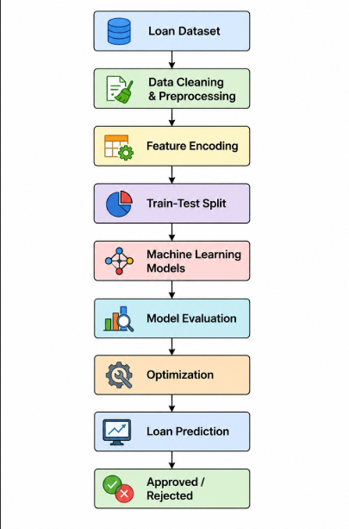
RESULTS AND EVALUATION

Evaluation Metrics

Accuracy
Measures overall prediction correctness.

Precision
Measures positive prediction quality.

Recall
Measures ability to identify positive cases.

F1 Score
Balance between precision and recall.

Confusion Matrix
Used to visualize prediction performance.

Example Results
Model | Accuracy
Logistic Regression | 84%
Decision Tree | 74%
Random Forest | 82%
Best Model:
Logistic Regression / Optimized Random Forest
ADVANTAGES AND APPLICATION

Advantages
- Faster decision making
- Reduced manual effort
- Improved consistency
- Better risk assessment
- Scalable solution

Applications
- Banking Sector
- Financial Institutions
- Credit Scoring Systems
- Loan Eligibility Screening
- Risk Management

CONCLUSION

This project successfully developed a machine learning-based loan approval prediction system. Data preprocessing, exploratory data analysis, and multiple classification algorithms were implemented. Performance comparison demonstrated the effectiveness of machine learning techniques for predicting loan approval outcomes.The optimized model achieved strong prediction accuracy and can support financial institutions in automating loan approval processes.

FUTURE SCOPE

- Deep Learning Models
- Real-Time Web Application
- Explainable AI
- Cloud Deployment
- Integration with Banking Systems

